**Electronic Eye Controlled Security System**

**4 |**



# Chapter 1 Introduction

## Introduction

Electronic Eye Controlled Security System is an electronic instrument that turns on a buzzer if someone is trying to forcibly enter a home. The primary principle of this system is to ring automatically when a person visits your home. This can also act as a smart doorbell. This system provides security when a person is trying to enter your home.

Electronic eye describes the design and implementation of LDR based Security Systems for homes, banks, malls etc. Where security is a major concern. The proposed system uses a light dependent resistor (LDR) to sense the light intensity. The LDR sensor senses the light intensity and generates an alarm for indicating thefts, and also turns on the lights.

In order to detect burglary, an LDR is used as the sensor. Light on the LDR determines whether a person is present or not. When there is any object at the entrance, LDR is in dark and buzzer starts ringing and the LED starts glowing.

**5 |**



* 1. **Design Goals/Objective**

The main principle of the circuit is to ring the doorbell when there is any person at the entrance. Light on the LDR determines whether a person is present or not. When there is any object at the entrance, LDR is in dark and buzzer starts ringing and the LED starts glowing.

# Chapter 2

**Design/Development/Implementation of Project**

* 1. **Design**

This circuit can be divided into two parts. One is the power supply and the other is the logic circuit. In the power supply circuit, a 9V supply from a battery is converted to the 5V. The logic circuit operates the buzzer and an LED when any shadow falls on the LDR.

* + 1. **List Of Equipment**

**6 |**



* + - * Bread Board (Mini)
      * IC 4049
      * Light dependent resistor (LDR)
      * 20K ohm resistor
      * LEDs (White-4) (Red-1)
      * Buzzer
      * Battery – 9V
      * Switches (4)
      * PVC/Foam Board (5mm)
      * Connecting Wires
      * Soldering Equipment
      * Hot Glue

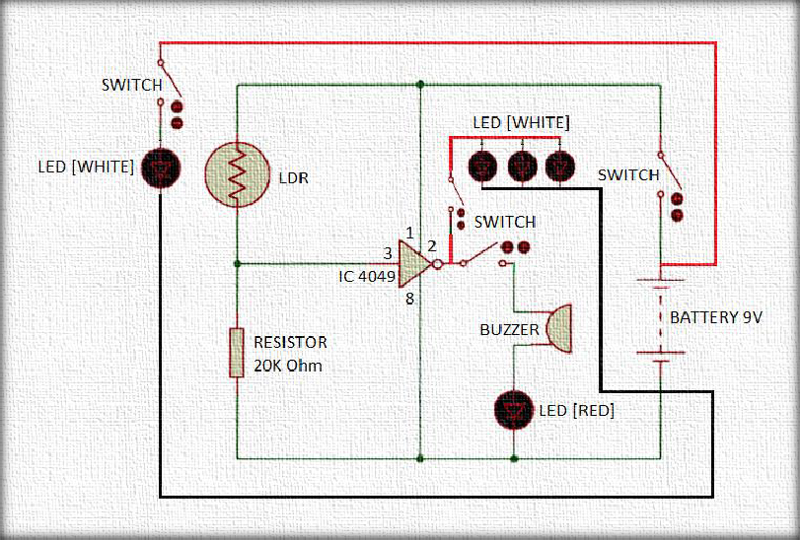

**Figure 2.1: Circuit Diagram**

* 1. **Circuit & Components Explanation**

**7 |**



A photodetector (LDR) is used in an electronic eye circuit to detect the presence of light. The light is then turned on and off by this device based on the intensity of light when it gets dark and vice versa.

To detect the presence or absence of light, LDRs are utilized. When the light intensity is very low (dark), the LDR has a very high resistance. The resistance decreases as soon as the LDR is exposed to light, and the amount depends on the light's intensity. LDR resistance, however, is inversely correlated with light intensity. Therefore, the voltage drop will be greater as light intensity increases.

Hex inverter buffer IC 4049, also used to convert high logic level to low, is utilized for this purpose. Due to its greater input supply voltage and 1mA current rating, the 4049 IC can manage two TTL loads. IC 4049 is mostly used to build voltage multiplier circuits. Another application for it is a square wave oscillator.

The components were put together according to the circuit diagram. Connected IC 4049 to the LDR. As indicated in the circuit diagram, connect the buzzer and the IC 4049. The power supply is linked to pin 1 of the 4049 IC, while pin 8 is grounded. Pin 3 is the input of the IC and we got our output from pin 2 of the IC. Connected the buzzer and LEDs to visualize the output of the circuit, as well as the switches to control the current flow.

# Chapter 3 Performance Evaluation

**8 |**



* 1. **Simulation Environment/ Simulation Procedure**

The Output primarily consists of the High and Low stages and cannot be in any other intermediate stages. In order to be portable, the circuit is powered by a 9v battery. We have only utilized one NOT gate in this circuit design, despite the fact that IC 4049 has six separate NOT gates.

Using an LDR and a 20k ohm resistor connected in series, we have created a

potential divider circuit. The output of the divider circuit will create greater voltages when the LDR is exposed to light, and vice versa, because voltage is exactly proportional to conductance.

The output voltage from the divider is then supplied into the input of the NOT gate of the Hex inverter 4049 IC. As a result, the output of the divider will be low when the level of light over the LDR is low (i.e., dark). As a result, the NOT gate IC's Pin 2 becomes high, activating the LED that is attached to the output. To put it simply, when LDR is not exposed to the light beam, its resistance decreases, which causes the hex inverter IC 4049 to produce a buzzing sound in the buzzer.

**9 |**

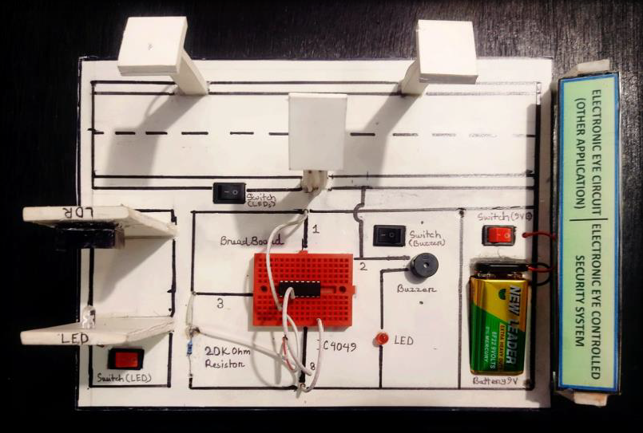

**Figure 3.1: Project Picture**

* 1. **Results and Discussions**

### Results/Analysis and Outcome

Electronic Eye Controlled Security System is a great technology by which you can monitor, control, and secure your home at less expense. This Project is user friendly and it can be easily implemented. With the electronic eye controlled security system, you can monitor, control and secure your home. This application saves money and minimizes energy consumption. It improves the overall efficiency of the system.

Electronic Eye controlled Security System device utilizes binary counter

as input. It has been successfully demonstrated that, this will serve as a device for providing security.

It provides the user with efficient and reliable security system for houses, malls etc., that supports the use of a binary counter which sense the intensity of light through LDR and activating the buzzer indicating a theft. This will serve as a device for securing personal wares in environments where it is deployed against intruders by setting off appropriate alarm for every door opens. Therefore, it can be said that the objectives of out project have been met.

**1**



# Chapter 4 Conclusion

* 1. **Introduction**

The main concept of this project is to design an Electronic Eye Controlled Security System for homes and public places like banks, malls, etc. This project uses an LDR sensor to sense the intensity of light and produces an alarm for representing thefts, and also switches ON the lights

Typically, an electronic eye is a photoresistor that activates the light when it gets dark. When operating a device in an area that is dark and without light, one can utilize an electronic eye-controlled security system. This system will automatically turn off if a light beam hits the surface of the LDR. This function has a wide range of applications in daily life and can be quite helpful.

* 1. **Practical Implications**

**1**



* It can be used as automatic guest indicator at the door in offices, schools, colleges and apartments.
* It can be used in security-controlled systems.
* This can be used in highway as vehicle counter, to count the number of vehicles
* It can be used in automatic wrapping machine in industries and factories to wrap materials that are manufactured
* It can be used in cameras to automatically determine the proper aperture and posture
  1. **Scope of Future Work**

The Electronic Eye Controlled Security System project can be enhanced by using a microcontroller and a GSM modem. The GSM based home security system can be interfaced with the microcontroller to send & receive an SMS to the authorized person in case of robbery.

# References

1. <https://www.electricaltechnology.org/2019/07/electronic-eye-circuit.html>
2. <https://www.elprocus.com/electronic-eye-controlled-security-system/>